2019 Summer Staff
Application

Steps to Becoming a Part of Briarwood
- Complete this application!
- Send in your application by mail, fax, or email. To send in by mail, send to:

Briarwood Retreat Center Attention: Program Team 670 Copper Canyon Road Argyle, Texas 76226

The fax number for Briarwood is (940) 455-7048 and emailed applications should be sent to:
program@briarwoodretreat.org
with “2019 Summer Staff Application” in the subject line.
- Arrange to have two reference letters on file with us. We encourage letters from church leaders, employers and teachers. Fill in your name on the attached forms and give to your references along with a stamped envelope. Have the reference forms mailed directly to us.
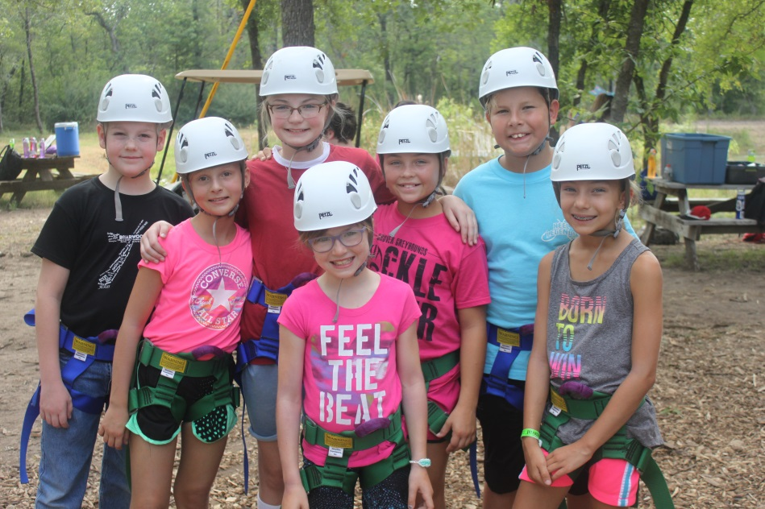
- After we receive your application and reference forms, we will contact you to arrange an interview.

About Briarwood

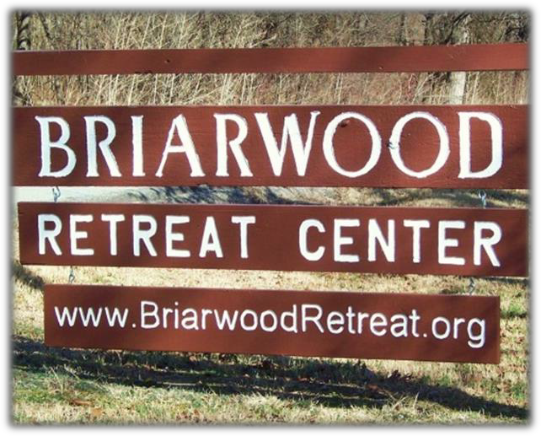
Briarwood is located between Denton and the Dallas/Fort Worth Metroplex. This diverse summer camp spans 60 acres, offering open fields for camp-wide games, miles of hiking trails through densely wooded groves of native oak, a pond stocked with fish for catch-and- release, a 50,000-gallon swimming pool to escape the intense summer heat, a rock wall and zipline, and eight outdoor chapels to feel God’s presence in a wide array of settings. Briarwood offers a variety of programs that make Briarwood a truly unique and amazing retreat from the city that surrounds it.
What Staff Need To Know

The summer camp season for 2019 begins with mandatory staff training, starting on Sunday, June 2nd and will go through June 14th. The summer camp sessions begin on June 16th and ends on August 4th. Significant time off during the training period or summer camp sessions may disqualify candidates from employment; however, exceptions can be made for important events such as graduations, college visits, family events or other approved time-off.

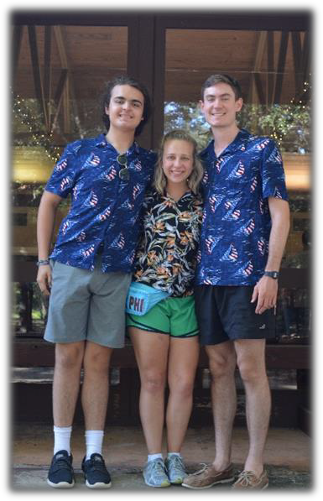
Staff will earn stipends based on camping leadership experience, special skills, certifications, and job responsibilities. Please remember that all stipends are in addition to housing, meals, and the experience of a lifetime! Staff will be paid for their time during the staff training periods based on experience and responsibilities. Base pay begins at $200 a week, and will increase based on added responsibilities and experience. A background check is required by both the State of Texas and the American Camping Association. We use this as a tool to offer the safest of environments for the children and adults who come to Briarwood. If you have any questions about our available positions, compensation, schedules, or anything else, please contact Madilyn Williams or Sarah Weaver, Program Interns of Briarwood Retreat Center, at (940) 241-2099.

Overnight Camp Life
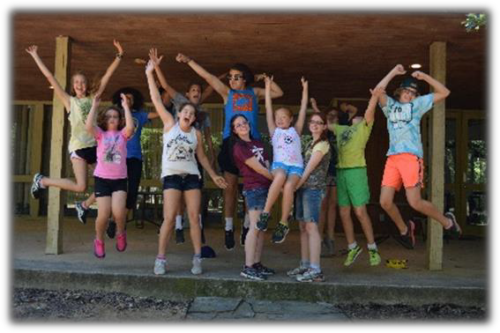
The camp week begins Sunday afternoon with the arrival of a new group of campers. Campers are split up into villages and are supervised by a team of two counselors. Counselors will lead their villages through activities throughout the week and watch over their cabin every night. Counselors act as teachers and friends as they guide their campers to a fun, safe and Christ-filled week. Villages will participate in the many activities Briarwood offers: worship, archery, biking, arts & crafts, team building exercises, devotions, swimming, canoeing, games, Bible study, rock wall/zipline, and campfires. The week ends on Friday afternoon with a family lunch and closing worship service.

Day Camp Team Life

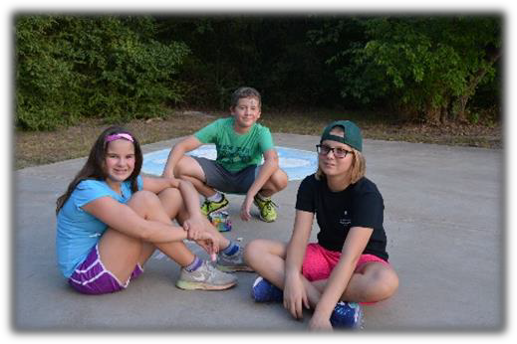
Day Camps are unique opportunities to bring the Briarwood experience to congregations throughout our Mission Area. Campers range from five to
ten years old and are able to enjoy summer camp without being away from home at night. The week begins on Sunday with an introduction to the
church and wraps up on Friday afternoon. The daily routine is similar to the site camp schedule in activities and breakdown of campers; however, the day ends in the afternoon and the children go home. This allows for free
time in the evening during which preparations for the following day and opportunities for recreation occur.

B.A.S.E. Camp!

This is a program offered by Briarwood that caters to our local community. Briarwood’s Awesome Summer Experience Camp (B.A.S.E. Camp) allows kids from the community to come enjoy all that Briarwood has to offer during the day, and go back home and
share with their family what they
experienced and learned during the evening. It’s a great way to introduce our young ones to the camp, and allows our older kids to have a safe and fun place to spend the day with their friends and family. B.A.S.E. Camp will be offered all summer long, and will have its own team working with the kids. The ages for B.A.S.E. Camp will be completed 1st – 6th Grade. There will be a B.A.S.E. Camp
Coordinator, and an Intern.

Briarwood 2019 Summer Staff Positions

Leadership Positions
21 years of age or older is preferred.
All Coordinators will be expected to arrive prior to Staff Training for Leadership Training and Summer Camp Prep.
Training will begin on May 30th, 2019, and will conclude with the beginning of Staff Training.

Program Assistant (1 Positions Available)
The Program Assistant will work with the year-round program staff to facilitate, manage, and create all aspects of the summer camp programs. They will work, help, build, and lead the Staff Training for all counselors, and be responsible for maintaining a safe and loving environment for all campers. They will be obligated by the general personnel policies for summer staff (covered during training). They will be directly responsible to the year-round program staff in all matters of conduct and business. The program assistant will also put together for Mission DFW week. They will work with the Program Team at Briarwood in developing curriculum and contacts for the Mission DFW Junior High Program. They will contact various agencies and companies to find locations for campers to go do service work, and help create devotions and bible studies for the evening. Experience in volunteer work is helpful, but not needed.

Arts & Crafts/Media Coordinator (1 Positions Available)
The A/C/M Coordinator will be in charge of teaching the counselors a variety of small easy arts and crafts during Staff Training that
they can easily teach their campers. The campers will be able to choose from the variety of crafts. The campers can also request a
guided craft from the coordinator relating to the theme or a more involved craft. The A/C/M Coordinator will be in charge of
replenishing the craft boxes that have all the supplies for the crafts each day. The A/C/M Coordinator will oversee taking pictures
and videos of campers and counselors. They will also teach counselors how to take pictures and videos on their phones and on the
camera. They will make the end of the week slideshows and assist in creating the staff training video. They will also be in charge of
posting to Briarwood’s social media accounts with updates each week.

Health Coordinator (1 Position Available)
The Health Coordinator is required to have CPR and First Aid certification, and lives on-site during the camp sessions to administer medications and tend to injured or ill campers. They are not only tasked with the physical health of the campers and counselors, but also the mental health. The Health Coordinator will need to be prepared to tend to homesickness, exhaustion, and stress. Experience in the health industry is preferred.

Overnight/Day Camp Coordinator (1 Position Available)
The Overnight/Day Camp Coordinator will oversee the overnight program and counselors.
They will take care of conflicts or issues with campers and counselors to the best of their ability. They will assist in
setups for worship and devotionals when needed. They will step in with activities if one counselor is on break or
indisposed at the moment and the activity requires two counselors. They will also be in charge of putting
together the day camp boxes and helping the day camp leads refill them. They will go over the responsibilities
and details of the day camp with the day camp team. They will be in charge of contacting each group every night
to recap on the day and resolve any issues they can.

B.A.S.E. Camp Coordinator (1 Position Available)
The B.A.S.E. Camp Coordinator will assist in coming up with the themes and curriculum of B.A.S.E. camp alongside the
program team. They will oversee the counselors and campers involved in B.A.S.E. camp and resolve any issues that might
arise to the best of their abilities. They will work with B.A.S.E. camp counselors to create the schedule for each day of camp.
They will oversee the arts and crafts and Bible Studies associated with B.A.S.E. camp.

Briarwood 2019 Summer Staff Positions

Counselors and Support Staff
High School Degree or equivalent is preferred.
All Staff are expected to be at the mandatory staff training, which starts on June 2nd, 2019.

Overnight Counselor/ Day Camp Counselor
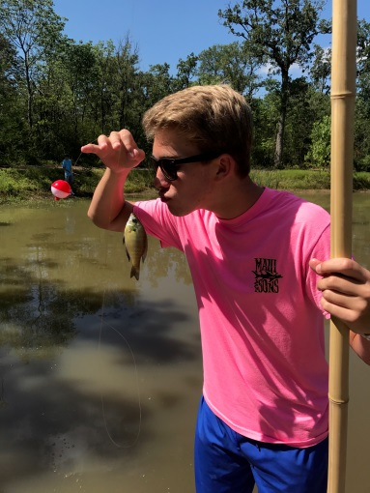
On-Site Counselors bring the ministry of Briarwood directly to the campers, living in cabins with campers, and helping them with all camp activities. On-Site Counselors work closely with other staff to help each camper grow and mature in their faith while enjoying the full camp experience. On-Site Counselors may also be assigned to participate in Day Camps, to work on support staff, or to fill another program role as necessary. The Day Camp Counselor serves to bring the ministry and experience of Briarwood to congregations throughout the Mission Area and beyond. All counselors must be at least 18 years old and have graduated from high school. Ability to play guitar or other instruments is a plus.

B.A.S.E. Camp Counselor
B.A.S.E. Camp Counselors help create a home away from home for our campers, creating a safe space for newcomers and returners alike. As their counselor, you will begin the week on Sunday, preparing for the week of camp. On Monday-Friday, you will greet the campers and their parents every morning, spend the day doing activities, Bible study, and games, and send them back home in the early evening. You will work with your coordinator to create the best experience possible for our campers, and further promote the program to the community.

Support staff
This summer we will have designated support staff members that will help with setting up and leading camp activities such as games, all-camps, swimming, biking, rock wall/zipline, worships, etc. They will also help with extra cleaning and preparations for groups that will rent out camp on the weekends. They will be a big part of ensuring the summer is as amazing as possible and helping the camp run smoothly. It is recommended they become lifeguard certified, first aid certified and rock wall/zipline certified through Briarwood. You must be at least 16 years old before the summer starts to apply for a support staff position.

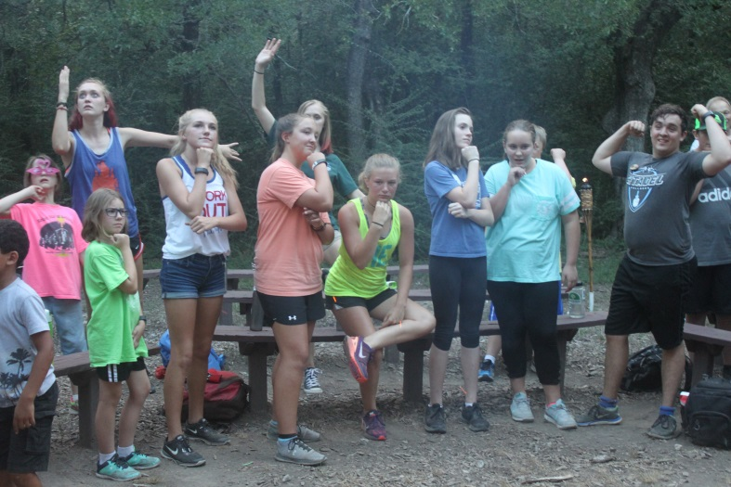
Acceptance and participation in our programs are the same for everyone without regard to race, color, age, sex, or national origin.

2019 Briarwood Summer Staff Application Form

Personal Information
Name |  |  |  |  |  |  |  |  |  |  |  | Gender
Address |  |  |  |  |  |  |  |  |  | Apt/Suite #
City |  |  |  |  | State |  |  |  |  |  | Zip Code
Cell Phone # |  |  |  | Home Phone #
Social Security # |  |  | Driver’s License # |  |  |  |  |  |  |  |  | State Issued
Date of Birth |  | E-mail  Address
Congregation/City

Position Desired:

Second Option:

Previous Work Experience (use separate sheet if necessary)

Employer | Dates Worked | Responsibilities

Educational Background (use separate sheet if necessary)

School Attended | Dates Attended | Major | Completed

Skills (What are you good at and interested in?)
Place a "1" by skills in which you hold Certification.
Place a "2" by skills that you know well enough to teach others. Place a "3" by skills that you could do with a group.
Place a "4" by skills that you are interested in. Leave the rest blank.

 | Bible  Study |  | Nature  Studies |  | Lifeguard |  | Canoeing |  | Guitar  Playing
 | Singing |  | Swimming |  | Arts &  Crafts |  | Camping  Out |  | Devotions
 | Story  Telling |  | Archery |  | Challenge  Course |  | Indoor  Games |  | Climbing
 | Sports |  | Outdoor  Activities |  | Cooking |  | Biking |  | Theater
Musical  Instruments |  |  |  |  |  | Other

Essay Responses (Feel free to use a separate sheet if necessary.)

      - Why do you want to work at Briarwood Retreat Center?

      - What are your gifts? How can you use those gifts this summer to build up our staff and campers?

      - How can your relationship with Jesus help you during this summer?

      - Are you able to make all of staff training and the entire summer camp season?

If no: please explain and list dates below:

References

List two references here. We encourage that one be your pastor or church youth leader; the others may include teachers or work supervisor. Give each reference a copy of the Reference Form included with this packet and ask them to mail it directly to us at the Argyle address.

Reference:

Address:

City: Zip: Phone:

Reference:

Address:

City: Zip: Phone:

Have you ever been convicted of a crime? Circle: Yes No If yes, please explain:

Employment Disclosure

When employment requires working in close proximity of children, Texas law provides for the furnishing of conviction records relating to crimes involving drugs, sex and violence. Criminal records will be checked before employment.
I certify that the answers given herein are true and complete to the best of my knowledge.
I authorize the investigation of all statements contained in this application for employment as may be necessary in arriving at an employment decision, including a criminal background history check.
The applicant understands that neither this document nor any offer of employment for the employer constitutes an employment contract unless a specific document to that effect is executed by the employer and employee in writing.
In the event of employment, I understand that false or misleading information given in my application or interview may result in termination of employment. I also understand that I am required to abide by all rules and regulations of the employer.

Signature of Applicant Date

Briarwood Reference Form

The person below is applying for the position of summer camp staff member at Briarwood Retreat Center, a Christian youth summer camp program. We hope to hire staff members who are servant-hearted, and able to build up and encourage those around them. Our staff members will live in close community with those around them, and should be able to manage conflict well, be open-minded, and be team players. Most importantly, we are looking for a staff that walks out their faith through loving those around them. Thank you for your time and consideration in completing this form. All responses will be kept confidential.

To Be Filled Out By Applicant

Applicant’s Name: is an active inactive _ associate member of Congregation Name: Address: City: St: Zip:

Please rate the following:

- Reliability

- Honesty

- Hard Worker

- "Team" Player

- Flexibility

- Emotional Stability Comments:

Poor Fair Good Excellent Superior

1 | 2 | 3 | 4 | 5
1 | 2 | 3 | 4 | 5
1 | 2 | 3 | 4 | 5
1 | 2 | 3 | 4 | 5
1 | 2 | 3 | 4 | 5
1 | 2 | 3 | 4 | 5

Please complete the following:

How well do you know the applicant?

Do you recommend the applicant? Why or Why Not?

In what areas can the applicant grow?

Signature: Printed Name:

Title/Position:

Please return this form promptly to: Briarwood Retreat Center
Attention: Program Team
670 Copper Canyon Road Argyle, Texas 76226
Phone: (940) 241-2099 FAX: (940) 455-7048

Briarwood Reference Form

The person below is applying for the position of summer camp staff member at Briarwood Retreat Center, a Christian youth summer camp program. We hope to hire staff members who are servant-hearted, and able to build up and encourage those around them. Our staff members will live in close community with those around them, and should be able to manage conflict well, be open-minded, and be team players. Most importantly, we are looking for a staff that walks out their faith through loving those around them. Thank you for your time and consideration in completing this form. All responses will be kept confidential.

To Be Filled Out By Applicant

Applicant’s Name: is an active inactive _ associate member of Congregation Name: Address: City: St: Zip:

Please rate the following:

- Reliability

- Honesty

- Hard Worker

- "Team" Player

- Flexibility

- Emotional Stability Comments:

Poor Fair Good Excellent Superior

1 | 2 | 3 | 4 | 5
1 | 2 | 3 | 4 | 5
1 | 2 | 3 | 4 | 5
1 | 2 | 3 | 4 | 5
1 | 2 | 3 | 4 | 5
1 | 2 | 3 | 4 | 5

Please complete the following:

How well do you know the applicant?

Do you recommend the applicant? Why or Why Not?

In what areas can the applicant grow?

Signature: Printed Name:

Title/Position:

Please return this form promptly to: Briarwood Retreat Center
Attention: Program Team
670 Copper Canyon Road Argyle, TX 76226
Phone: (940) 241-2099 FAX: (940) 455-7048

